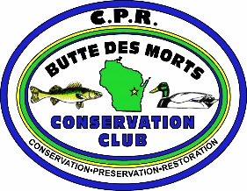
BDMCC JULY 11, 2016
GENERAL MEMBERSHIP MEETING MINUTES
Terrell’s Island Classroom
7:00pm
The meeting was called to order at 7:02 p.m.
Communications:
The Muskey project is underway and currently funded.
Secretary’s Report:
The Secretary’s Report was read and accepted without correction.
Treasurer’s Report:
There was no Treasurer’s Report.
Old Business
a. Property Update—The Club’s pontoon boat is in the water at the dock in the breakwall. The Club is awaiting an invoice from Hergert’s for the boat repairs. Badger signs emailed the updated sign designs to Kelly and they were reviewed. A boat cover is needed for the pontoon.
b. Golf Outing—On Saturday, July 16th, Randy Pointon and Pete Ehlert will make a trip to Green Bay to get framed prints to use as prizes at the Golf Outing. Posters have been hung locally. There are still posters available.
c. Wiouwash Trail—The Club’s second trail cleanup of the season will take place on Tuesday, July 19th at 6:30pm. A reminder was sent in the June Marsh Talk. Meet by the trail off of Westwind Road. All supplies will be provided.
Adjournment: A motion to adjourn the meeting was made first by Don Stowe and second by Randy Pointon. The meeting was adjourned at 7:41 p.m.

Members/Guests present:
Pete Guckenberg, Randy Pointon, Don Stowe, Kelly Reyer, Neil Janssen, Bruce Loberg.

